Find a website with a problematic user interface / lacks usability and submit your answers in word document for the following 5 questions:

- URL of site evaluating
https://kijo.co.uk

- Targeted audience
Users who would want a website designed for them, usually business owners who need help designing a website.

- Things you like
  - I like the font used for the website
  - I like how when you click something on the website it shows this screen

  - Above the fold there is an option that lets you tell about the project you want made by them, which is straightforward.
  - There are some transitions in the wordings when you scroll down
  - I like the colors used in the webpage
  - Their icon looks great
  - URL is short and easy to type
  - I like how they give you specific options you need help with
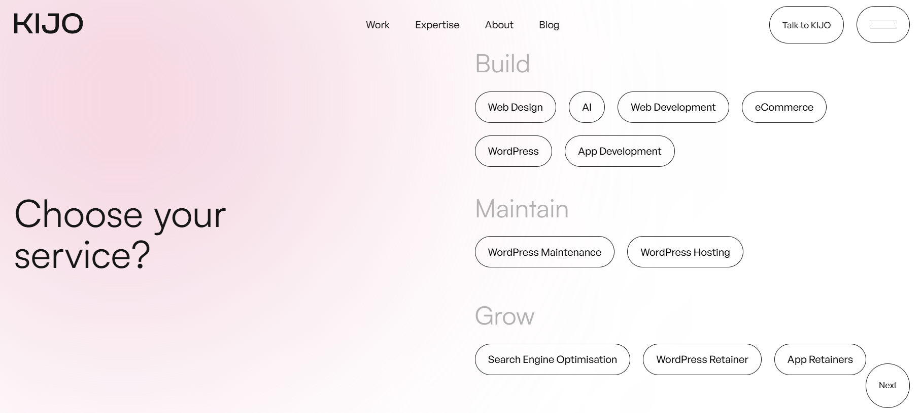

- Things I don’t like
  - Size of letters is too big
  - Scrolling is a bit weird because there is a bit of delay.
  - Some images are not weird
  - When hovering over a text or image, there is a circle for you to select but I just find it very unnecessary and over the top.
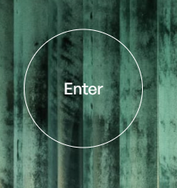
  - When clicking on something in the website, it takes a considerable amount of time to actually get into another page
  - The overall layout and design of the website is quite mediocre for me
  - Information being given down the page does not really have any relevance to creating web pages.
  - Scrolling to the end of the page is too long.

- Suggestions for Improvement
  - I suggest changing the whole design of the page
  - Keep buttons simple
  - Remove the delay in the scrolling and just use the default scroll
  - Ensure faster loading times to other parts of the web page.
  - Avoid using big letters and images
  - Remove the ‘Select’ circle when hovering over images

